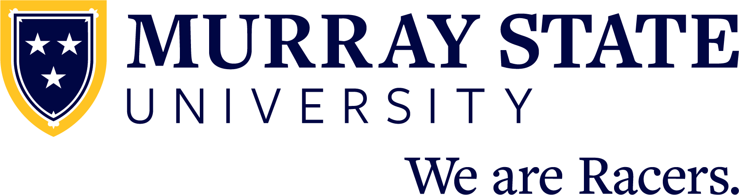

FOR IMMEDIATE RELEASE: Month Day, 20XX

(Student name) graduates from Murray State University

MURRAY, Ky. — (Student name) from (city, state and/or country) has graduated from Murray State University with a (Bachelor/Master/Doctorate/etc.) of (Arts/Science/etc) in (major).

(Student name) is the (child) of (parent/guardian name or names).

(INCLUDE ACADEMIC HONORS/AWARDS HERE)

Murray State University hosted commencement ceremonies for fall and winter 2025 graduates on Saturday, Dec. 13 at the CFSB Center.

A total of 768 degree applicants from 28 states and 14 countries comprised the graduating class including doctoral, specialist, master’s, baccalaureate and associate degrees.

Recognized as one of America’s best college values, Murray State has been recognized nationally for both quality and value by the following publications:

Washington Monthly - “Best Bang for the Buck”
Wall Street Journal - “Best Colleges in the United States”
Niche - “Best Colleges in Kentucky”
Colleges of Distinction - “Best Colleges”

Murray State has also been recognized as a member of the FirstGen Forward Network and has achieved silver status by Military Friendly as a Military Friendly school.

Admission for the fall 2026 semester and 2026-27 academic year at Murray State University is open as future Racers should apply today at admissions.murraystate.edu. Students interested in joining the Racer family can also learn more as well as schedule a campus visit by calling the office of recruitment at 270-809-2896 or emailing msu.recruitment@murraystate.edu.

Since 1922, Murray State University has provided a collaborative, opportunity-rich living and learning community that fosters personal growth and professional success through a high-quality college experience. Students receive support from inspiring faculty and staff and will join a distinctive campus community — the Racer Family. Murray State prepares the next generation of leaders to join more than 80,000 successful alumni who make a difference in their community, across the country and around the world. The University’s main campus is located in Murray, Kentucky, and includes five regional campuses in Ft. Campbell, Henderson, Hopkinsville, Madisonville and Paducah. Learn more at murraystate.edu.

