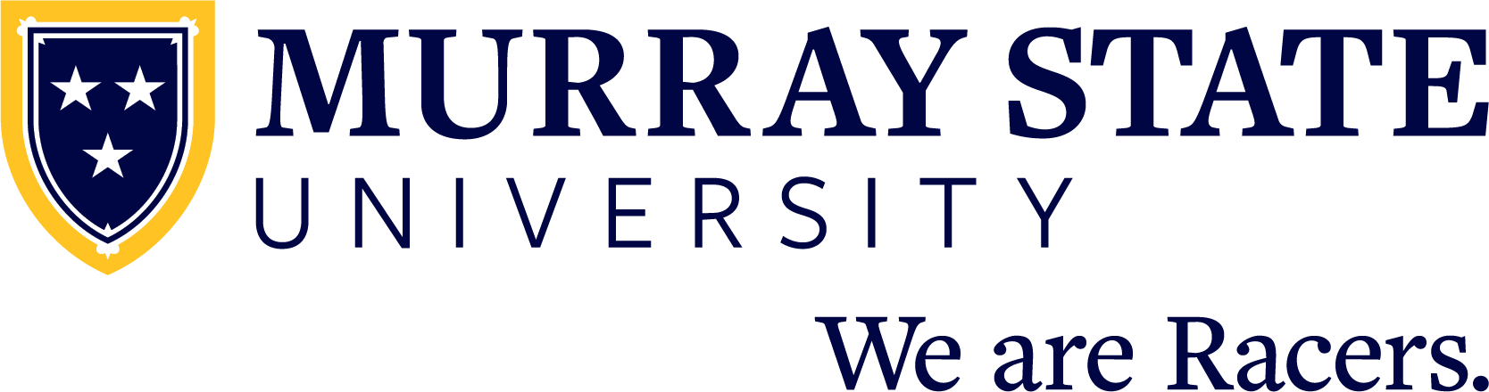

FOR IMMEDIATE RELEASE: Month Day, 20XX

(Student name) graduates from Murray State University

MURRAY, Ky. — (Student name) from (city, state and/or country) has graduated from Murray State University with a (Bachelor/Master/Doctorate/etc.) of (Arts/Science/etc) in (major).

(Student name) is the (child) of (parent/guardian name or names).

(INCLUDE ACADEMIC HONORS/AWARDS HERE)

Murray State University hosted commencement ceremonies for fall 2023 graduates on Saturday, Dec. 9 at the CFSB Center.

A total of 739 degree applicants from 25 states and 13 countries comprised the graduating class including doctoral, specialist, master’s, baccalaureate and associate degrees.

Recognized nationally as one of America’s best college values, Murray State has been named by U.S. News & World Report as one of the top universities in the country for 33 consecutive years. Murray State was also highlighted within the past year as a best value for students seeking a college degree by Washington Monthly in its “Best Bang for the Buck” rankings, as well as by Forbes, Money Magazine and the Wall Street Journal/Times Higher Education.

Admission for the 2024-25 academic year at Murray State University is open as future Racers can apply today at admissions.murraystate.edu. Students interested in joining the Racer family can also learn more as well as schedule a campus visit by calling the office of recruitment at 270-809-2896 or emailing msu.recruitment@murraystate.edu.

Since 1922, Murray State University has provided a collaborative, opportunity-rich living and learning community that fosters personal growth and professional success through a high-quality college experience. Students receive support from inspiring faculty and staff and will join a distinctive campus community — the Racer Family. With nearly 10,000 students, Murray State prepares the next generation of leaders to join more than 80,000 successful alumni who make a difference in their community, across the country and around the world. The University’s main campus is located in Murray, Kentucky, and includes five regional campuses in Ft. Campbell, Henderson, Hopkinsville, Madisonville and Paducah.

Learn more at murraystate.edu.

